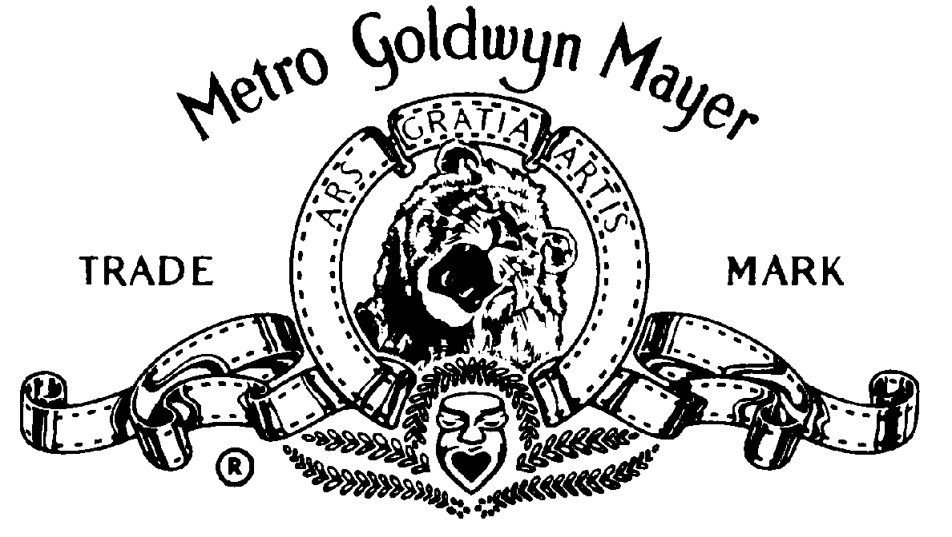

WHAT’S THE WORST THAT COULD HAPPEN?
Color Press Kit Captions

M-387 MARTIN LAWRENCE stars as professional thief Sean Caffrey in Metro-Goldwyn-Mayer Pictures’ comedy WHAT’S THE WORST THAT COULD HAPPEN?.
Photo Credit: Sam Emerson

M-35 DANNY DEVITO stars as millionaire Max Fairbanks in Metro-Goldwyn-Mayer Pictures’ comedy WHAT’S THE WORST THAT COULD HAPPEN?.

Photo Credit: Sam Emerson

M-118 MARTIN LAWRENCE (left) and DANNY DEVITO star in Metro-Goldwyn-Mayer Pictures’ comedy WHAT’S THE WORST THAT COULD HAPPEN?.

Photo Credit: Sam Emerson

M-109 DANNY DEVITO (left) and MARTIN LAWRENCE star in Metro-Goldwyn-Mayer Pictures’ comedy WHAT’S THE WORST THAT COULD HAPPEN?.

Photo Credit: Sam Emerson

M-169 MARTIN LAWRENCE (left) and JOHN LEGUIZAMO star in Metro-Goldwyn-Mayer Pictures’ comedy WHAT’S THE WORST THAT COULD HAPPEN?.
Photo Credit: Sam Emerson

M-170 JOHN LEGUIZAMO (left) and MARTIN LAWRENCE star in Metro-Goldwyn-Mayer Pictures’ comedy WHAT’S THE WORST THAT COULD HAPPEN?.
Photo Credit: Sam Emerson

M-147R WILLIAM FICHTNER (left) and MARTIN LAWRENCE star in Metro-Goldwyn-Mayer Pictures’ comedy WHAT’S THE WORST THAT COULD HAPPEN?.
Photo Credit: Sam Emerson

M-362R MARTIN LAWRENCE and CARMEN EJOGO star in Metro-Goldwyn-Mayer Pictures’ comedy WHAT’S THE WORST THAT COULD HAPPEN?.

Photo Credit: Sam Emerson
M-186 (Left to right) GQ, BERNIE MAC, MARTIN LAWRENCE and JOHN LEGUIZAMO star in Metro-Goldwyn-Mayer Pictures’ comedy WHAT’S THE WORST THAT COULD HAPPEN?.
Photo Credit: Sam Emerson

M-152 MARTIN LAWRENCE (left) and BERNIE MAC star in Metro-Goldwyn-Mayer Pictures’ comedy WHAT’S THE WORST THAT COULD HAPPEN?.

Photo Credit: Sam Emerson

M-191 NORA DUNN and DANNY DEVITO star in Metro-Goldwyn-Mayer Pictures’ comedy WHAT’S THE WORST THAT COULD HAPPEN?.

Photo Credit: Sam Emerson

M-209 SASCHA KNOPF and DANNY DEVITO star in Metro-Goldwyn-Mayer Pictures’ comedy WHAT’S THE WORST THAT COULD HAPPEN?.

Photo Credit: Sam Emerson

M-200 RICHARD SCHIFF (left) and DANNY DEVITO star in Metro-Goldwyn-Mayer Pictures’ comedy WHAT’S THE WORST THAT COULD HAPPEN?.

Photo Credit: Sam Emerson

M-215 GLENNE HEADLY and DANNY DEVITO star in Metro-Goldwyn-Mayer Pictures’ comedy WHAT’S THE WORST THAT COULD HAPPEN?.

Photo Credit: Sam Emerson

M-188 (L to R, backseat) SIOBHAN FALLON, LENNY CLARK, JOHN LEGUIZAMO, ANA GASTEYER, MARTIN LAWRENCE, and (front seat) BERNIE MAC star in Metro-Goldwyn-Mayer Pictures’ comedy WHAT’S THE WORST THAT COULD HAPPEN?.
Photo Credit: Sam Emerson

M-324 SAM WEISMAN (left) directs MARTIN LAWRENCE (center) and JOHN LEGUZAMO in Metro-Goldwyn-Mayer Pictures’ comedy WHAT’S THE WORST THAT COULD HAPPEN?.
Photo Credit: Sam Emerson

M-325R DANNY DEVITO (left) and Director SAM WEISMAN on the set of Metro-Goldwyn-Mayer Pictures’ comedy WHATS THE WORST THAT COULD HAPPEN?.
Photo Credit: Sam Emerson

CN-6-5A MARTIN LAWRENCE stars as professional thief Sean Caffrey in Metro-Goldwyn-Mayer Pictures’ comedy WHAT’S THE WORST THAT COULD HAPPEN?.
Photo Credit: Eric Lee

13091 MARTIN LAWRENCE (left) and DANNY DEVITO star in Metro-Goldwyn-Mayer Pictures’ comedy WHAT’S THE WORST THAT COULD HAPPEN?.

Photo Credit: Eric Lee

